The Price of Mission and Strategy Management Misconduct
Alexander Gromoff, Prof.
Faculty of Business and Management
Business Informatics School, National Research University "Highest School of Economics"
Moscow, Russia
alexander.gromoff@me.com

«Wrong articulation of the mission and goals result in time and energy wasting on carefully implemented actions which need not at all».

P. F. Drucker – the XX cen. Management’ guru

Abstract— This work was carried out by the undergraduates of Business Informatics School of the National Research University “Higher School of Economics” in early 2019. Four months later, a catastrophe occurred at Sheremetyevo Airport, which claimed lives. One could believe in coincidence and blame everything on the “human factor” if earlier similar disasters did not occur in Domodedovo and Vnukovo Airports under very similar circumstances, correlated with leitmotif of this work. The term ‘misconduct’ is mainly used in the fields of government, police, criminal senses but here the case of faulty professional management is offered to be considered as misconduct.
The students of the magistrate I.E. Brovkova, A.A. Murzakova, E.A. Murzakova, E.A. Rybachenko, D.M. Ryabova and A.S. Talankin took active roles in preparation of the case study and particularly "Aeroflot" strategic goals and mission analysis. The paper deals with the problem of enterprise management in process of strategic planning building and ways to solve it. Planning and selection of strategies have a great influence on the ways to complete the tasks and the final goals of the company. Incorrectly chosen strategies or their incorrect definition (articulation) can affect negatively the efficiency of the company and the significance and priority of the management, monitoring and control tasks of executive processes, so the relevance of this problem should be considered from essential point of view. The purpose of the article is to demonstrate the influence of the strategic objectives and the mission of the company on the business processes and the operational risks of management processes in the field of mission critical activities.
Keywords— System analyses, strategic goals, mission, business processes, enterprise management, planning, balanced scorecard, SMART, company goals, STS.

Management problem statement
The conceptual basis of enterprise management as a sociotechnical system (STS) lies in the field of modeling the behavior of complex, large systems. The concept of a large, complex system was introduced in system analysis not for the purpose of classification (large or small), but to highlight the way in which the behavior of the controlled systems is considered with the diversity of the processes taking place in them, united by the common goals of STS functioning. Each system is a subsystem of another larger system (super-system in relation to itself). The total number of communications inside such system can be enormous, and accordingly the management of any complex system is a tricky task, since any control based on information exchange i.e. communication.
The management process main components are the organization developing goal, a development strategy, a development model, a model for motivating and stimulating efficient activity of processes [1]. The reflexive component should be added in the modern management model not in the form of simple feedback info loop, but as an independent regulatory component with self-adoption ability.
Any activity is carried out from the certain goal achieving standpoint. At the first stage, STS determines the goals significant for the market and consumers. The next step is the formation of an action plan to achieve the stated goal [2]. The effective functioning of enterprise in dynamic external environment is determined by degree of senior management being capable to use tools and methods for strategic planning and further implementation.
Strategic planning is one of the key management functions, which involves determination of the enterprise goals and the ways to achieve these goals. The strategic plan describes the global vision of the company's development prospects and is the basis for making management decisions. In modern conditions, the strategic interests of organizations are in the pursuit of sustainable development and adaptation to the effects of the external environment. The higher the uncertainty and dynamics of environmental factors, the more urgent for an enterprise is the problem of strategic plan development and implementation [3].
The essence of strategic management is determined by the formation and implementation of an organization's development strategy based on continuous monitoring and evaluation of ongoing changes in its activities in order to maintain the ability to survive and effective operation in the unstable external environment. The framework of strategic management is a system of strategies. At the same time, STS strategy is a pre-planned reaction to the risk of changes in external environment, and a principle of STS behavior chosen to achieve the desired result. Strategic management includes the formation of the mission and vision of the enterprise, goals, strategic analysis, diagnostics of the internal and external environments.
Strategic management in an enterprise is expressed in the following five functions [4]:
• Strategy planning;
• Organization of the strategic plans’ implementation;
• Coordination of activities for the strategic objectives’ implementation;
• Motivation to achieve strategic results;
• Control over the process of strategy implementation.
Importantly, speaking about the strategic management, is the role of balanced scorecard methodology (BSC). The BSC allows to lead and get over the strategy to each employee, motivate to achieve reflexively responsible achievement of the results and control the process of carrying out the relevant strategic goal.
Statistics show that half of Russian enterprises do not effectively use the strategic planning tool. At the same time, few haven’t even strategy declaration of an excuse of “it’s better not to promise anything than to not achieve what you did promise”. The inefficient management systems include those where the deviation of the actual results from the planned is more than 20-30% [5]. That clearly underscored the seriousness of the current situation, because the strategic plan is the fundamental basis of the management activities of any enterprise, but still the management literacy of many STS is based on mantra "if I got it, I know some".
Unfortunately, the time-driven race for financial performance and senior management vanity leads to catastrophic errors and realization of operational risks that have cumulative effect, which is often called the “Butterfly Effect”, but unfortunately not Travis Scott’s lyrics.
Under strategic management the following problem situations occur:
• Strategy is not formalized. There are ideas about it, but not gotten over to the staff, not analyzed from the point of view of the relevant objectives’ implementation processes;
• There is no conceptual and technological connection between the strategy and the organizational solutions, that used, the goals are declared by themselves, and the processes of activity exist by themselves, according to the principles “it has always been like this” or “we have the best specialists do this”;
• Control focuses only on financial aspects;
• Each unit has its own set of KPIs (key performance indicators), often without vision of interrelation between;
• KPIs are unbalanced, strategy unoriented and unrelated to them;
• The KPIs selected for different types of activities contradict each other, as they are formed from the interests of specific managers of the process-functional control loops.
Misunderstanding the importance and nature of strategic planning can lead to a deterioration of company’s activity indicators, increasing risk, reducing the competitiveness. But nothing new from the said above could be found during last 20, 30,…years, and even in antient Greeks or Romeos one can find a number of stratagem’s considerations that are still valid. So wrong management in defining mission and strategy goals has to be qualified as misconduct without of excuse of lack of knowledge. More than two thousand years ago Chinese philosopher and warrior Sun Tzu wrote in his ‘The Art of War’ “…directing many use 4 with 2 basic each (4 hieroglyphs constructed from 2 elementaries)… and just to selected 10 near you explain the goals in details…”. Is it any different from Drucker’s rule of ‘eight-words mission statement’ for open community? Civilization history is a teacher of Strategic management achievements and faults.
The true Strategic Management (SM) has to form clear, transparent vision of enterprise development and its potential risk. As well analysis of the strategic basic components has to diagnose the STS management system and to develop the improvement steps for the end-to-end and cross-cutting processes.

Approach to strategic management solution
In order to avoid accusation in management misconduct because of financial, resource or time risk realization resulting in industrial, technogenic or human catastrophes and inconsistencies with the originally set goals and strategic plans, STS management has to control definition and articulation of the mission and strategy following next 12 steps:
1. The mission analysis in terms of STS social significance;
2. The mission semantic decomposition into strategic goals, sub-goal tree and elimination of processes and functions at least in 4 aspects (market, finance, process, staff);
3. Key performance indicators (KPIs) identification for each strategic goal;
4. Modeling, description of activity cross-cutting process with auxiliary "sleeves";
5. Identification of the core processes (realizing the goals) involved in cross-cutting process;
6. Determination of the measurement points with metrics for each process;
7. Particular role definition for each step (function) of the process and its performers;
8. Development for each process of technology (automatic or automated) metrics collection and aggregation;
9. Determining who is responsible for the aggregation points;
10. Development of optimal (competence, experience, knowledge, socialization) of the organizational structure for the resulting model;
11. Provision (to reach agreement) to the performers to describe, model the process of their activities;
12. Motivate process participants to proceed change/improvement proposals [1, 6-8].
It is imperative that the mission and the strategy to be clear for both company employees and customers. Company needs to monitor the implementation of KPIs, following and reflecting the strategy in predefined processes, as well controlling changes in the external environments and market reaction on resulting outputs.
It is important for Executive Board to motivate all employees to create a system that would be a leader in their industry and would be beneficial throughout the community. One positive reference reflected in blog’s 3 repeats, but one negative response reacts 12 -15 repeats. People keen to acuse.
The mission as the upper level goal of socially oriented efforts should be correctly, accurately farticulated and distributed. Further, during mission evolution into strategic goals an effective program should be involved for internal relations marketing, personnel marketing, ongoing training and advanced training, strategies for achieving of leadership level in external market.

The case study of strategic goals and mission analysis
For the case study the mission of ‘Aeroflot’ randomly was chosen among others big STS. The articulated meanings of business and its purposes for the society are reflected as follows:
“We are working to ensure that our customers can quickly and comfortably travel great distances, which means – to be mobile, meet more often, work successfully and see the world in all its diversity.
We give our customers the opportunity to choose thanks to the extensive route network and various air carriers of the Group: from low-cost airlines to premium level.”
It seems bright, the company cares about the mobility and comfort of the client, that corresponds to modern trends and challenges. But besides mobility and comfort customer-passenger is seriously concerned about security-care. In these declarations, safety is not mentioned in any meanings. It may be a marketing ploy not to focus passenger’ attention on this issue, and everything is included in the strategy.
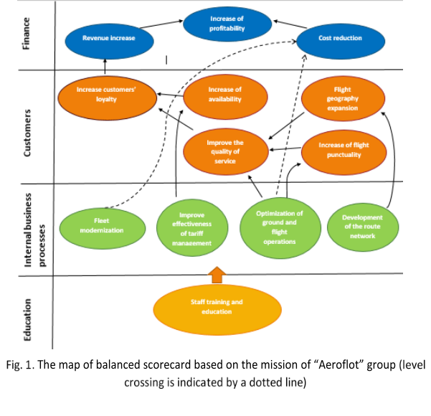
Consider the strategic goals as a tool for process management, which are the real tasks facing the business, and therefore, each strategic goal must have a specific process to achieve it. If the goal is absent, it is not formulated, then there is no corresponding process of activity among the processes of critical and primary importance. For PJSC "Aeroflot" strategic goals for 2018 were designated as follows:
1. By 2025 – the Top 5 European air carriers in terms of revenue and passenger traffic;
2. By 2025 the Top 20 Global airlines by revenue and passenger’s turnover;
3. By 2025, the volume of passenger traffic is more than 70 million passengers a year, 30 million of them on the domestic market;
4. Development of transit traffic through the hub in Moscow;
5. Wild market presence providing.
The mission and strategic goals are directly related to each other and are a logical continuation of each other, but reflect the different levels of the company. In the case of PJSC «Aeroflot» obviously that the mission is client-oriented, the company stresses the importance of comfort and choice of the customer, whereas the strategic objectives concentrated on improving financial performance, which implies that the company’s objectives is the increase of profitability, and thus on the interests and needs of the customers attention is not focused, why? Is this a formal declaration posted on the company's website, but the mission and strategy are freely available, that the company does not understand the inconsistency of its statements or does not understand the meaning of these statements.
This discrepancy is also evident in the representation of the map of BSC on the basis of the mission and on the basis of strategic objectives. Fig. 1 depicts the map of balanced scorecard based on the mission of the group "Aeroflot" in wording to 2019.
In fact, the lack of mention of “security” in the mission and strategic wordings makes it impossible to establish the KPI on this indicator, it disappears from the balanced scorecard, and therefore from the monitoring and control system. At the same time, operational risks throughout the entire trajectory of the safety processes multiply, as if there is no end-to-end control was provided by the BSC, then the probability of error increases dramatically. If we recall the practice of military production acceptance in the 60-80s, then it was the system of end-to-end control and the CRC, which ensured the highest reliability of products and the safety of personnel.
The map of BSC based on the strategic objectives is presented on Fig. 2 in wordings to 2019. The figures 1 and 2 demonstrate that the main difference is concentrated in the perspective of "Customers". Thus, the key goal, based on the mission, is to increase customer satisfaction, based on these strategic goals to increase the number of passengers transported.
Consider the 2018 strategic goals of Aeroflot group for compliance with the SMART principle (specific, measurable, achievable, relevant, time-limited), because while no one has proposed any other method for target determination analyzing from the standpoint of semantic-content decomposition.
Strategic objectives № 1 and №2 do not meet the criterion Specific (specificity). There is not specified which top is meant, who compiled this rating, which airlines are considered.
Strategic objective № 3 does not meet the criterion of specificity, as the concept of "broad presence in the market" is abstract, and the criterion of Measurable (measurability), as it is difficult to measure, in the absence of a predetermined metric characterizing the concept.
Strategic objective № 4 does not meet the Measurable criterion, as the indicators characterizing the development are not indicative. This objective is also not specific, there is a lack of clarity about the expected result.
The Time-bound (determinacy through time) criterion is not considered in strategic objectives №4 and №5, since there are no deadlines for the implementation of tasks.
Therefore, strategic objectives do not meet the criteria of Specific, Measurable and Time-bound to some extent. As for the Relevant criterion (Relevance, Materiality), the analyzed objectives should be discussed with the management of the companies after analyzing the company's vision from the points of view of Threats, Opportunities, Strengths and Weaknesses (SWOT analysis).
From the strategic objectives, it is possible and necessary to logically derive the main processes of PJSC “Aeroflot”, which should ensure the achievement of the set goals; these processes can be divided into three groups:
1. Management processes:
- strategic management;
- financial management;
- marketing management;
- human resource management.
2. The main processes:
- selling of air transportation;
- flight operation of aircraft;
- development of multi-brand platform;
- development of transit traffic through the Moscow hub.
3. Supporting processes:
- aircraft maintenance of flights;
- ground support of flights;
- security provision;
- facilities.
Fig. 3 shows business processes of the top-level, built in accordance with strategic objectives.
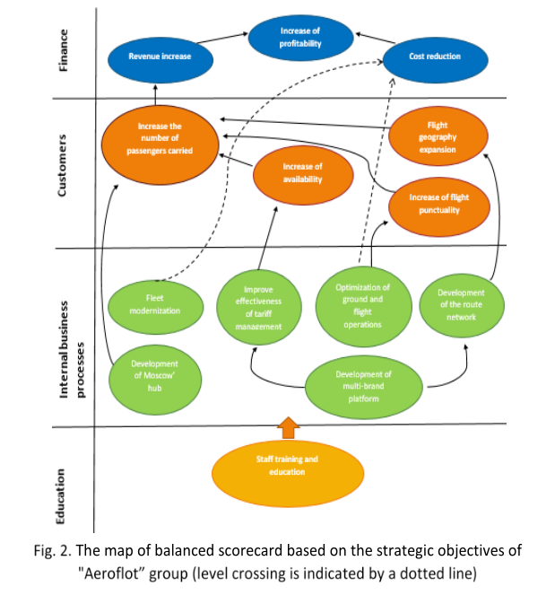
On November 1, 2018 the Board of Directors of PJSC Aeroflot - Russian Airlines adopted the new Development Strategy of the Aeroflot Group until 2023. The new strategy within the digital transformation includes five points:
1. Carry 90-100 million passengers in 2023;
2. Increase the international transit passenger traffic from 5 million in 2017 to 10-15 million in 2023;
3. Open by 2023 new regional bases: Sochi, Yekaterinburg, Novosibirsk and the international hub in Krasnoyarsk;
4. Operate 200 SSJ-100 and MC-21 aircraft by 2026;
5. Provide an advanced level of digitalization for Group airlines [12-13].
Analyzing as previously, it’s obviously that objectives №1 and №2 are consistent with the SMART. method, however, passenger traffic range can be misleading, because it is unclear whether the goal will be achieved if the passenger traffic exceeds the specified numbers. Goal number 3 corresponds to the method of SMART. Goal number 4 are consistent with the SMART. method, however, it is beyond the time limit for which the strategy was adopted.
Goal number 5 is completely inconsistent with the SMART method:
• Specific - it’s not clear what the advanced level of digitalization means.
• Measurable – such goal setting makes it impossible to measure the level of digitalization.
• Achievable – such goal setting makes it impossible to determine its reachability.
• Relevant – such goal setting makes it impossible to assess the relevance and effect of the goal.
• Time bound – no timeframes for the goal.
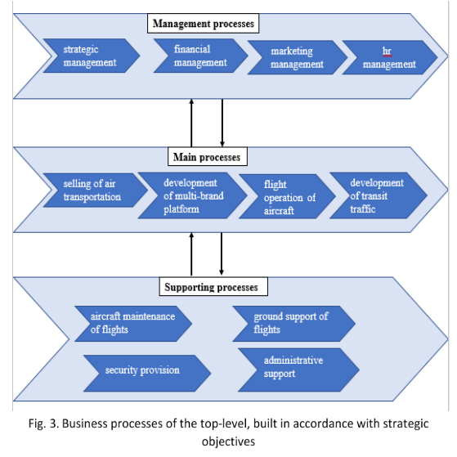
According to the results of the analysis, we see that four goals out of five almost completely correspond to the rules of goals setting. The fifth goal violates the five rules of the SMART. methodology, so it is impossible to evaluate its implementation. The fact is that Aeroflot PJSC calls their strategy a digital transformation strategy, but four goals out of five are not directly related to digital transformation, and the only relevant goal is unattainable due to the wording problems.
In addition, if to analyze the interdependence of goals, it turns out that only the first goal is the top-level goal, independent of the others, and the others, except the fifth, work for it. And again, there is not a word about security, it should again be noted that in the wording of strategic goals there should not be anything “accepted by default”, because every word in strategic wordings has reflection in the activities and specific actions.
BSC map is at Fig. 4 is based on the strategic goals for 2019 of PJSC "Aeroflot". From the strategic goals it is possible and necessary logically to derive the main processes of the Aeroflot group, which should ensure the achievement of the goals set. These processes can be divided into three groups:
1. Management processes:
— strategic management;
— financial management;
— marketing management;
— personnel management
2. Main processes:
— airline sales;
— aircraft operation;
— development of regional bases and hubs;
— expansion of the aircraft fleet
3. Ensuring processes:
— aircraft technical support;
— ground flight support;
— security;
— increasing the level of digitalization;
— facilities
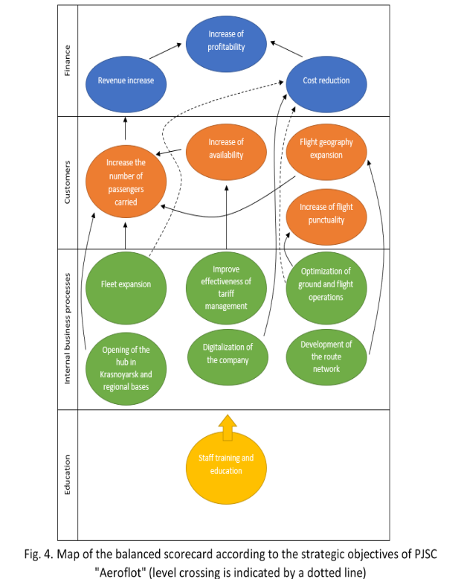

Below is a diagram of the top-level business processes, built in accordance with the strategic objectives (Fig. 5).
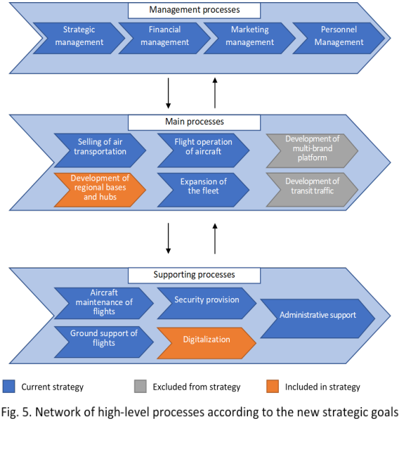
When comparing business processes arising from two versions of strategic goals, in the case of 2018 year goals, the main processes are aimed at increasing passenger traffic and revenue. In the new goals there are new directions, such as the development of regional bases and hubs, the expansion of the aircraft fleet, so PJSC Aeroflot intends to increase transportation between regions and contribute to their economic development, as well as relieve the main hub in Moscow. Within the framework of supporting processes, a business process appears connected with the digital transformation of the Aeroflot group. Thus, with the achievement of new goals, Aeroflot Group plans to reach a new level of operating activities, maintaining the status of the main Russian airline.

Conclusion and issue price
As a result of the Aeroflot group mission and strategies analysis, differences were revealed between the goals that the mission and strategies set for the company in 2018. This reflects in the balanced scorecard map. Although in 2018 all the strategic goals of the company were achieved, it is impossible to assert that its mission has been achieved. From the point of view of the SMART principle, strategies do not satisfy all items, because of this, staff of the company may have different ideas about each strategy and how to achieve it. This factor may affect the decrease in work efficiency.
Due to the difference in strategic objectives in 2018 and 2019, the company's business processes must be changed. In 2019 year, they must be aimed also at increasing the fleet of domestic aircraft and the development of domestic inter-regional transport. This difference is due to changes in the economic and political environment. Whereas the company is a sociotechnical system that is inextricably linked with the outside world, in order to survive, it must be able to adapt to changes and set goals correctly.
It seems that the distance from the statement of the goal to the real actions of the crew is great, however, each strategic goal must be decomposed to the level of the processes and functions that ensure its achievement. So the declaration of “flight safety” in the strategy is decomposed into a multi-level system of events covering all aspects of safety, from the quality of in-flight catering to the preparation of the flight personnel, from the quality of the technical maintenance of the aircraft in the slot to the preparedness of the RWY (runway), with the corresponding control points and KPI (key performance indicators) at all levels. However, PJSC decided to “replace” safety by “to put 200-s of ‘Superjet 100’ and ‘MS-21’ aircrafts on the wing until 2026” and actually all the strategy is focused on increasing passenger traffic, i.e. solely on financial performance. It should also be noted that the change of strategic formulations twice a year indicates a formal attitude to strategy and ostentatious marketing.
Any company, any STS must pay special attention to the strategies and the missions setting, forming and articulating, relying on changes in external environment in order to build the most effective way to achieve the chosen/dictated goals. Each word, each comma in the definitions of strategy and mission could play a crucial role, and the price of mistake here is life lost, infirmity, and crippled fates. The purpose of this work is not to identify the errors and accuse particular company, a similar coincidence in the time of analysis and subsequent catastrophe is random (need to believe), but the same situation with the strategy construction without significant study of the definitions and wordings with the existing processes of activity is observed widely, practically everywhere. The absence of the imputed level of security in strategic planning as a factor of monitoring, control and management is not just a critically dangerous risk, but a real brake on the economy development.
And finally, never mind who or what is the prime factor that led to catastrophe - silliness, ambitions, greediness or felonious misconduct, all priced the lifes.

References

- V.R. Vesnin, “Strategic Management”. Textbook, Moscow: Prospect, 2015. - 328 p.
- A.I. Gromoff, “Business Process Management: Modern Methods”. Monograph, Moscow: Yurayt Publishing, 2017. - 368 p.
- E.A. Borgardt, “Strategic Management of Sustainable Development of an Enterprise”, No. 1, Actual Problems of Economics and Law, 2013, pp. 55-61.
- I.V. Popova, “The Role of Enterprise Strategic Management in the Modern Conditions of a Market Economy”, No. 9-1, Symbol of Science, 2016, pp. 144-146.
- Hussein Labib Ali, “The Role of Strategic Planning in the Development of Enterprise Productivity,” No. 1, Vestnik USOTU . Science, education, economics. Series: Economy, 2018, p. 98-103.
- V.D. Markova, S.A. Kuznetsova, “Strategic Management”. Tutorial, Moscow: Infra-M Publishing House, 2008. - 287 p.
- STPLAN.RU. Strategic management and information planning. Formation of the enterprise the mission and objectives [Electronic resource]. - Access mode: http://www.stplan.ru/articles/theory/goals.htm. - (Date of appeal: 12/29/2018);
- Solution of the company's strategy with the quality management system relationship problem [Electronic resource]. - Access mode: http://quality.eup.ru/MATERIALY10/intercoupling.htm. - (Date of circulation: 01/04/2019);
- A.M. Zhemchugov, M.K. Zhemchugov, “Purpose as a basis for strategy”, No. 8, Problems of Economics and Management, 2014. - pp. 9-17.
- S.V. Mishchenko, “A mission, vision, quality policy, goals, and strategic plans development under introducing a quality management system in an organization”, No. 1, Vestnik of Tambov State Technical University, 2005. - pp. 198-210;
- M.V. Miroslavskaya, “Actual issues of mission formation in the framework of the strategic management of large industrial companies”, No. 10, International Journal of Humanities and Natural Sciences, 2018. - pp. 100-104.
- Aeroflot. Strategy [Electronic resource]. - Access mode: https://ir.aeroflot.ru/ru/company-overview/strategy/. - (Date of circulation: January 4, 2019);
- Aeroflot. Strategy and development [Electronic resource]. - Access mode: https://www.aeroflot.ru/ru-ru/about/strategy. - (Date of appeal: 01/04/2019).

